-- EXERCISE 13

-- 1. Which command displays the MySQL version?

SELECT VERSION();
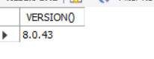

-- 2. Use the SELECT command to evaluate 4 × 4 × 4 and name the column Cube of 4.

SELECT (4 * 4 * 4) AS 'Cube of 4';
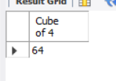

-- 3. Display your name using SELECT.

SELECT 'Recelle May B. Janda' AS 'Name';
